Managing Current Location

Getting Your Current Location (Get-Location)

To determine the path of your current directory location, enter the Get-Location command:

PowerShellCopy

Get-Location

OutputCopy

Path

----

C:\Documents and Settings\PowerUser

Note

The Get-Location cmdlet is similar to the pwd command in the BASH shell. The Set-Location cmdlet is

similar to the cd command in Cmd.exe.

Setting Your Current Location (Set-Location)

The Get-Location command is used with the Set-Location command. The Set-Location command allows

you to specify your current directory location.

PowerShellCopy

Set-Location -Path C:\Windows

After you enter the command, you will notice that you do not receive any direct feedback about the effect

of the command. Most Windows PowerShell commands that perform an action produce little or no

output because the output is not always useful. To verify that a successful directory change has occurred

when you enter the Set-Location command, include the -PassThru parameter when you enter the SetLocation command:

PowerShellCopy

Set-Location -Path C:\Windows -PassThru

OutputCopy

Path

----

C:\WINDOWS

The PassThru parameter can be used with many Set commands in Windows PowerShell to return

information about the result in cases in which there is no default output.

You can specify paths relative to your current location in the same way as you would in most UNIX and

Windows command shells. In standard notation for relative paths, a period (.) represents your current

folder, and a doubled period (..) represents the parent directory of your current location.

For example, if you are in the C:\Windows folder, a period (.) represents C:\Windows and double periods (..)

represent C:. You can change from your current location to the root of the C: drive by typing:

PowerShellCopy

Set-Location -Path .. -PassThru

OutputCopy

Path

----

C:\

The same technique works on Windows PowerShell drives that are not file system drives, such as HKLM:.

You can set your location to the HKLM\\Software key in the registry by typing:

PowerShellCopy

Set-Location -Path HKLM:\SOFTWARE -PassThru

OutputCopy

Path

----

HKLM:\SOFTWARE

You can then change the directory location to the parent directory, which is the root of the Windows

PowerShell HKLM: drive, by using a relative path:

PowerShellCopy

Set-Location -Path .. -PassThru

OutputCopy

Path

----

HKLM:\

You can type Set-Location or use any of the built-in Windows PowerShell aliases for Set-Location (cd,

chdir, sl). For example:

PowerShellCopy

cd -Path C:\Windows

PowerShellCopy

chdir -Path .. -PassThru

PowerShellCopy

sl -Path HKLM:\SOFTWARE -PassThru

Output Screenshot:

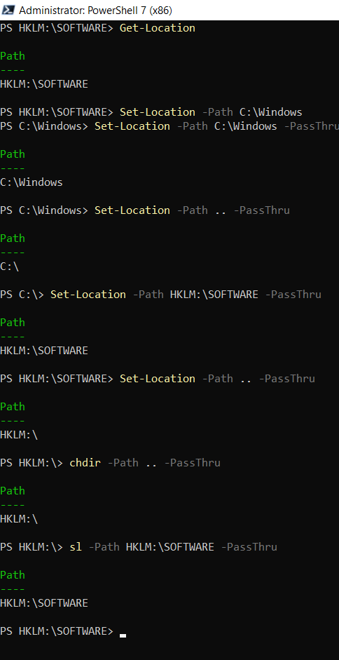

Saving and Recalling Recent Locations (Push-Location

and Pop-Location)

When changing locations, it is helpful to keep track of where you have been and to be able to return to

your previous location. The Push-Location cmdlet in Windows PowerShell creates a ordered history (a

"stack") of directory paths where you have been, and you can step back through the history of directory

paths by using the complementary Pop-Location cmdlet.

For example, Windows PowerShell typically starts in the user's home directory.

PowerShellCopy

Get-Location

Path

----

C:\Documents and Settings\PowerUser

Note

The word stack has a special meaning in many programming settings, including .NET Framework. Like a

physical stack of items, the last item you put onto the stack is the first item that you can pull off the stack.

Adding an item to a stack is colloquially known as "pushing" the item onto the stack. Pulling an item off

the stack is colloquially known as "popping" the item off the stack.

To push the current location onto the stack, and then move to the Local Settings folder, type:

PowerShellCopy

Push-Location -Path "Local Settings"

You can then push the Local Settings location onto the stack and move to the Temp folder by typing:

PowerShellCopy

Push-Location -Path Temp

You can verify that you changed directories by entering the Get-Location command:

PowerShellCopy

Get-Location

OutputCopy

Path

----

C:\Documents and Settings\PowerUser\Local Settings\Temp

You can then pop back into the most recently visited directory by entering the Pop-Location command,

and verify the change by entering the Get-Location command:

PowerShellCopy

Pop-Location

Get-Location

OutputCopy

Path

----

C:\Documents and Settings\me\Local Settings

Just as with the Set-Location cmdlet, you can include the PassThru parameter when you enter the PopLocation cmdlet to display the directory that you entered:

PowerShellCopy

Pop-Location -PassThru

OutputCopy

Path

----

C:\Documents and Settings\PowerUser

You can also use the Location cmdlets with network paths. If you have a server named FS01 with an share

named Public, you can change your location by typing

PowerShellCopy

Set-Location \\FS01\Public

or

PowerShellCopy

Push-Location \\FS01\Public

Output copy:

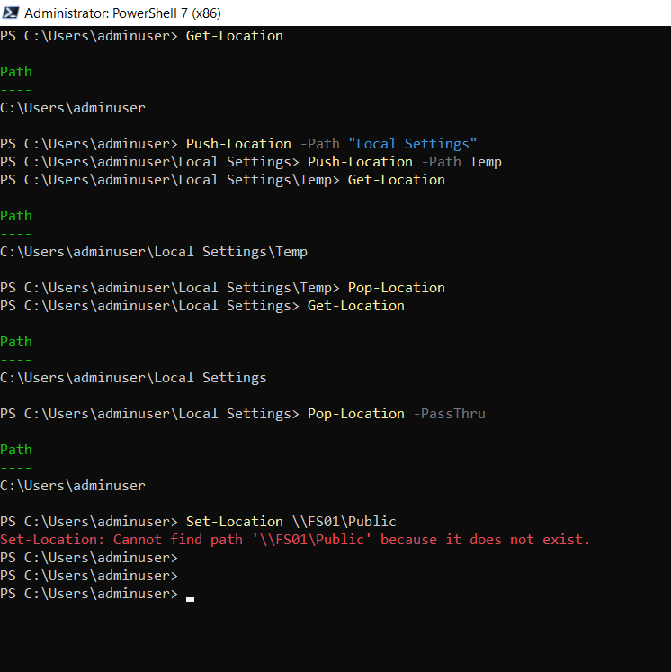

You can use the Push-Location and Set-Location commands to change the location to any available drive.

For example, if you have a local CD-ROM drive with drive letter D that contains a data CD, you can change

the location to the CD drive by entering the Set-Location D: command.

If the drive is empty, you will get the following error message:

PowerShellCopy

Set-Location D:

OutputCopy

Set-Location : Cannot find path 'D:\' because it does not exist.

When you are using a command-line interface, it is not convenient to use File Explorer to examine the

available physical drives. Also, File Explorer would not show you the all of the Windows PowerShell drives.

Windows PowerShell provides a set of commands for manipulating Windows PowerShell drives, and we

will talk about these next.

